


Title



Trade Hunter’s meeting minutes

Third Year Of Computer Engineering

Authors:
Julen Gabilondo, Peru Ramos, Unai Laskurain, Andoni Usandizaga And Xabat Maortua
24th of January of 2024
Index
Figure index III
1 Initial meeting 1
2 First week (11/12/2023 - 17/12/2023) 3
2.1 Daily meeting (11/12/2023) 3
2.2 Daily meeting (12/12/2023) 3
2.3 Daily Meeting (13/12/2023) 5
2.4 Daily meeting (14/12/2023) 7
2.5 Daily meeting (15/12/2023) 9
3 Second week (18/12/2023-24/12/2023) 11
3.1 Replenishment and Commitment Meeting (18/12/2023) 11
3.2 Daily meeting (18/11/2023) 12
3.3 Daily meeting (19/12/2023) 14
3.4 Daily meeting (20/12/2023) 16
3.5 Service delivery review (21/12/2023) 18
4 Fifth Week (08/01/2024 – 14/01/2024) 21
4.1 Service delivery meeting (08/01/2024) 21
4.2 Replenishment and Commitment Meeting (08/01/2024) 23
4.3 Daily meeting (08/01/2024) 25
4.4 Daily meeting (09/01/2024) 27
4.5 Daily meeting (10/01/2024) 28
4.6 Daily meeting (11/01/2024) 30
4.7 Daily meeting (12/01/2024) 32
5 Sixth week (15/01/2024-21/01/2024) 34
5.1 Replenishment and Commitment Meeting (15/01/2024) 34
5.2 Daily meeting (15/01/2024) 35
5.3 Daily meeting (16/01/2024) 37
5.4 Daily meeting (17/01/2024) 38
5.5 Daily meeting (18/01/2024) 40
5.6 Daily meeting (19/01/2024) 41
6 Seventh week (22/01/2024-24/01/2024) 44
6.1 Replenishment and Commitment Meeting (22/01/2024) 44
6.2 Daily meeting (22/01/2024) 45
6.3 Daily meeting (23/01/2024) 47
6.4 Daily meeting (24/01/2024) 49
6.5 Service delivery meeting (24/01/2024) 50
6.6 Strategy review meeting (24/01/2024) 53

Figure index
3-1. Figure: Lead time (21/12/2023) 19
3-2. Figure: Gantt diagram (21/12/2023) 20
4-1. Figure: Lead time (08/01/2024) 22
4-2. Figure: Gantt diagram (08/01/2024) 23
6-1. Figure: Final lead time (24/01/2024) 52
6-2. Figure: Final Gantt diagram (24/01/2024) 53
6-3. Figure: WIP limit graph (24/01/2024) 55

Initial meeting
Date: 04-12-2023
Time: From 8:00 to 8:30
Location: Mondragon University 11310
Attendees:
- Service Delivery Manager: Unai
- Service Request Manager: Peru
- Team: Xabat, Andoni and Julen
Agenda:
- Introduction and definition of the project
- Kanban roles and responsibilities
- Product backlog and work Items
- Project phases and life cycle
- Kanban policies
- Gantt chart and initial planning
Meeting summary:
- Introduction and definition of the project:
  - The "Trade Hunter" project aims to address prevalent issues faced by investors in the stock market, with a focus on developing a robust AI model for reliable stock market predictions.
- Kanban roles and responsibilities:
  - Service Delivery Manager (SDM): Unai Laskurain
  - Service Request Manager (SRM): Peru Ramos
  - Team Members: Julen Gabilondo, Andoni Usandizaga, Xabat Maortua
- Product backlog and work items:
  - Detailed breakdown of key tasks, including REST server creation, login system, automation method with Jenkins, registration system, data collection, Python server, user edition, historical data retrieval, simulation with threads, web predictions, real-time data collection, Gmail bot implementation, forum system, and recommendation system.
- Project phases and life cycle:
  - Defined project phases: Pending, Design, Implementation, Validation, Deploy.
  - Emphasized the importance of structured progression from design to deployment.
- Kanban policies:
  - WIP limit set to 5 items to optimize team focus.
  - Prioritization among projects/tasks based on importance.
  - Classes of services defined for task categorization.
  - Clear guidelines for handling blocked items, capacity utilization, and balancing.
- Gantt chart and initial planning:
  - Presented a coherent Gantt Chart outlining the initial plan, focusing on the REST server, web development, and subsequent AI model and forum system implementation.
- Next steps:
  - Team members to review and provide feedback on the defined roles, product backlog, and project phases.
  - Implementation of Kanban policies and initiation of the defined tasks.
Open Discussion:
In conclusion, the initial meeting has successfully laid the foundation for the "Trade Hunter" project. With a clear definition of project objectives, assigned roles, and a comprehensive breakdown of tasks, the team is well-equipped to embark on the development journey. The emphasis on Kanban methodologies, structured project phases, and defined policies provides a robust framework for efficient workflow management. The Gantt Chart serves as a visual guide for the team's upcoming tasks, offering a coherent and realistic plan. Moving forward, effective collaboration and adherence to the outlined strategies will be crucial for achieving the project's goals. The team expresses enthusiasm and commitment to delivering a successful and impactful solution for stock market investors.

First week (11/12/2023 - 17/12/2023)

Daily meeting (11/12/2023)
Date: 11-12-2023
Time: From 8:00 to 8:30
Location: Mondragon University 11310
Attendees:
- Service Delivery Manager: Unai
- Service Request Manager: Peru
- Team: Xabat, Andoni and Julen
Agenda:
- Coordination and planning for the day ahead.
Daily Minutes:
- What did I do yesterday?
  - Team:
    - Meeting with Ane to define how to manage the management of the project.
- What will I do today?
  - Team:
    - Initial planning meeting.
- What is in my way?
  - Team:
    - Nothing to comment.
Open Discussion:
The members are clear about their role in the project and it has been correctly defined which procedure has to be followed in order to correctly run the project management. The next step is to proceed with the development of the project, each with their assigned tasks.

Daily meeting (12/12/2023)
Date: 12-12-2023
Time: From 8:00 to 8:30
Location: Mondragon University 11310
Attendees:
- Service Delivery Manager: Unai
- Service Request Manager: Peru
- Team: Xabat, Andoni and Julen
Agenda:
- Coordination and planning for the day ahead.
Daily Minutes:
- What did I do yesterday?
  - Unai:
    - Do the part of the project’s life cycle and definition of roles of the project management’s initial document.
  - Xabat:
    - Define explicit policies rules for the project management’s initial document.
  - Peru:
    - Do the introduction of the project management’s initial document and define product backlog and work items to initiate.
  - Andoni:
    - Describe the Gantt chart and project schedule in the project management’s initial document.
  - Julen:
    - Do the introduction of the project management’s initial document and define product backlog and work items to initiate.
- What will I do today?
  - Unai:
    - Create the Jenkinsfile to automatize the git merge from develop to master and the SonarQube analysis.
  - Xabat:
    - Create the Jenkinsfile to automatize the git merge from develop to master and the SonarQube analysis.
  - Peru:
    - Search information for the AI server and identify the attributes that will be taken into account in the AI prediction.
  - Andoni:
    - Search information for the AI server and identify the attributes that will be taken into account in the AI prediction.
  - Julen:
    - Create the login and register part in the REST server.
- What is in my way?
  - Unai:
    - Deciding what commands will be automatized in the Jenkinsfile.
  - Xabat:
    - Deciding what commands will be automatized in the Jenkinsfile.
  - Peru:
    - Correctly identifying the work items and the subtasks of the product backlog.
  - Andoni:
    - Getting sure that no more than 5 PBIs are done simultaneously during the entire project.
  - Julen:
    - Correctly identifying the work items and the subtasks of the product backlog.
Open Discussion:
The team made significant progress yesterday in defining roles, initiating project documentation, and outlining the project's structure. Today's goals centre around automation, AI research, and server functionality development. However, challenges persist in finalising automation commands, accurately defining work items within the backlog, and managing the number of concurrent tasks. The overarching focus remains on streamlining processes, conducting research, and ensuring clarity and efficiency in project execution.

Daily Meeting (13/12/2023)
Date: 13-12-2023
Time: From 8:00 to 8:30
Location: Mondragon University 11310
Attendees:
- Service Delivery Manager: Unai
- Service Request Manager: Peru
- Team: Xabat, Andoni and Julen
Agenda:
- Coordination and planning for the day ahead.
Daily Minutes:
- What did I do yesterday?
  - Unai:
    - Create the Jenkinsfile to automatize the git merge from develop to master and the SonarQube analysis.
  - Xabat:
    - Create the Jenkinsfile to automatize the git merge from develop to master and the SonarQube analysis.
  - Peru:
    - Search information for the AI server and identify the attributes that will be taken into account in the AI prediction.
  - Andoni:
    - Search information for the AI server and identify the attributes that will be taken into account in the AI prediction.
  - Julen
    - Create the login and register part in the REST server.
- What will I do today?
  - Unai:
    - Implement the google cloud server and download and install the different technologies that are going to be used, such as Jenkins, SonarQube…
  - Xabat:
    - The client’s register and login in NODE-RED. Also find how to switch between different pages of the frontend.
  - Peru:
    - Implement the google cloud server and download and install the different technologies that are going to be used, such as Jenkins, SonarQube…
  - Andoni:
    - Make initial model with the internal factors with all the phases: Preprocessing, modelling and validation.
  - Julen:
    - Create the login and register part in the REST server.
- What is in my way?
  - Unai:
    - Download the Jenkins server on the cloud and make a connection with this.
  - Xabat:
    - Deciding what are the correct type of NODE-RED components that are going to be used.
  - Peru:
    - Download the Jenkins server on the cloud and make a connection with this.
  - Andoni:
    - Adapt the data of the dataset of the project to the model.
  - Julen:
    - Make an efficient connection with the REST API and other components such as NODE-RED, MySQL…
Open Discussion:
The team made significant progress yesterday in the area of REST service by doing the initial functions in it, searching for relevant data, and making the initial structure in the NODE-RED server. Today's goals centre around Google Cloud server installation and implementation, AI research, and server functionality development. However, challenges persist in finalising automation commands. The overarching focus remains on streamlining processes, conducting research, and ensuring clarity and efficiency in project execution.

Daily meeting (14/12/2023)
Date: 13-12-2023
Time: From 8:00 to 8:30
Location: Mondragon University 11310
Attendees:
- Service Delivery Manager: Unai
- Service Request Manager: Peru
- Team: Xabat, Andoni and Julen
Agenda:
- Coordination and planning for the day ahead.
Daily Minutes:
- What did I do yesterday?
  - Unai:
    - Install Jenkins and SonarQube in the cloud.
  - Xabat:
    - Do the registration, login, and the frontend of the website.
  - Peru:
    - Installed Jenkins and SonarQube in the cloud.
  - Andoni:
    - Looking at the model for use in AI (Time Windows)
  - Julen:
    - Schema of xml for web.
- What will I do today?
  - Unai:
    - Working in the cloud, installing node-red.
  - Xabat:
    - Continue working on the web, doing the search function.
  - Peru:
    - Implementing SonarQube in Cloud Service.
  - Andoni:
    - Start with the model of IA (Prophet).
  - Julen:
    - Make the Python server and try to connect to the WEB server.
- What is in my way?
  - Unai:
    - Configure Cloud and install node-red there.
  - Xabat:
    - Continue adding functionalities to the Web, this time making the search function.
  - Peru:
    - Install SonarQube in the Cloud Service.
  - Andoni:
    - Make the new AI model following the Prophet structure. Taking in a count the time windows.
  - Julen:
    - Make the Python server and then be able to connect it to the Web through InfluxDB.
Open Discussion:
The group has made good progress in the cloud part, since it has managed to start up the cloud server. In addition to this, in the web part, it has been managed to make several functionalities of this, such as login or register. The functionalities for today are to start making the AI model with time windows, that is to say, to use the Prophet model. In the cloud it will have to install all the programs needed such as Node-Red and SonarQube. Finally on the web what will be done will be to make more functionalities.

Daily meeting (15/12/2023)
Date: 15-12-2023
Time: From 8:00 to 8:30
Location: Mondragon University 11310
Attendees:
- Service Delivery Manager: Unai
- Service Request Manager: Peru
- Team: Xabat, Andoni and Julen
Agenda:
- Coordination and planning for the day ahead.
Daily Minutes:
- What did I do yesterday?
  - Unai:
    - Installed Jenkins and SonarQube in the cloud.
  - Xabat:
    - The frontend of the website.
  - Peru:
    - Installed Jenkins and SonarQube in the cloud.
  - Andoni:
    - Start doing the model of Prophet.
  - Julen:
    - Try to implement InfluxDB.
- What will I do today?
  - Unai:
    - Installed Jenkins and SonarQube in the cloud.
  - Xabat:
    - The frontend of the website.
  - Peru:
    - Installed Jenkins and SonarQube in the cloud.
  - Andoni:
    - Start doing the model of Prophet.
  - Julen:
    - Implement InfluxDB
- What is in my way?
  - Unai:
    - Jenkins port is not changing.
  - Xabat:
    - Toolbar customization.
  - Peru:
    - The integration of different tools in cloud.
  - Andoni:
  - Add new rows in the dataset.
  - Julen:
    - Problems with Python environments.
Open Discussion:
During today's meeting at Mondragon University on December 15, 2023, the team displayed significant advancements in both cloud and web development. Notably, the successful initiation of the cloud server was highlighted as a major achievement. In the web domain, several functionalities, including login and register features, were successfully implemented. Looking ahead, the team's focus is on building an AI model using the Prophet model, specifically incorporating time windows. Today's agenda includes the installation of necessary programs such as Node Red and SonarQube in the cloud. Additionally, on the web front, the plan is to further enhance and develop additional functionalities, highlighting the team's commitment to progress on both fronts.

Second week (18/12/2023-24/12/2023)

Replenishment and Commitment Meeting (18/12/2023)
Date: 18-12-2023
Time: From 8:00 to 8:30
Location: Mondragon University 11309
Attendees:
- Service Delivery Manager: Unai
- Service Request Manager: Peru
- Team: Xabat, Andoni and Julen
Agenda:
- Review the performance of the team during the past week.
- Discuss if the limit of the WIP is suitable for the team.
- Check for the presence of blocked items.
- Decide the priority of the PBIs selected.
- Discuss if new PBIs are required for the correct development of the project.
Discussion Summary
- Performance in the past week:
  - The team's performance in the last week has been good. The majority of the objectives set for the week have been achieved, and the results obtained have been as desired. Team members have worked well together, dividing various tasks among themselves, and following the planned schedule.
- WIP suitability:
  - The WIP limit that was decided has been suitable regarding the project development, as only 5 PBIs were developed simultaneously.
- Blocked items:
  - So far, the group has not encountered any major problems with the tasks assigned, so there are no items that are blocked.
- PBI priority selection:
  - There were two tasks that should have been finished by the end of the last week but that couldn’t be finished. These tasks are collecting external data factors and developing the Jenkins automatization. As a result, these two PBIs will be the ones with the higher priority.
  - The task to create the user edition has to be done by the end of this week, so this will also have a high priority, but lower than the previous two tasks.
- New PBIs:
  - It has been decided to create a welcome page or home page. In this page the user will be welcomed to the page, showing its name and so on. In addition, a burger menu is going to be implemented where new actions could be possible to perform in the future.
  - A new functionality has been decided to implement in the project to create a data impact analysis on the web, so that the user sees the impact of the data in the stock market index. This has been decided to implement this week, so this will also have a high priority, along with the user edition.
Action Items:
- Complete the PBIs for data decision-making:
  - Ensure the successful closure of outstanding Product Backlog Items (PBIs) related to data decision-making. This involves ending tasks, documenting outcomes, and achieving alignment with project objectives.
- Attempt to prevent the occurrence of blocked items:
  - Implement proactive measures to identify and address potential obstacles before they escalate. Foster open communication within the team to promptly resolve any issues hindering progress.
- Strive to keep the WIP below the set limit of 5:
  - Make a concerted effort to manage the Work in Progress (WIP) and ensure that the number of concurrent tasks remains below the established limit of 5. This involves careful planning and coordination to optimize workflow efficiency.
- Maintain the good performance of the team for this week:
  - Uphold the positive performance exhibited by the team in the previous week. Encourage collaboration, effective communication, and a focus on achieving individual and collective goals to sustain the high standard of work.
Conclusions:
In conclusion, the team had a positive week with effective collaboration. The WIP limit of 5 PBIs proved suitable, and no major issues were encountered. Two tasks from the previous week require immediate attention, while new priorities include creating the user edition and implementing a data impact analysis. Action items involve completing pending PBIs, preventing blockages, staying below the WIP limit, and maintaining the team's strong performance.

Daily meeting (18/11/2023)
Date: 18-12-2023
Time: From 8:30 to 9:00
Location: Mondragon University 11309
Attendees:
- Service Delivery Manager: Unai
- Service Request Manager: Peru
- Team: Xabat, Andoni and Julen
Agenda:
- Coordination and planning for the day ahead.
Daily Minutes:
- What did I do yesterday?
  - Unai:
    - Installed Jenkins and SonarQube in the cloud and opened ports to become operative.
  - Xabat:
    - Design the web. Put the logo of Trade Hunter on the toolbar of the website. Start doing the home page where searches and predictions are going to be made.
  - Peru:
    - Installed Jenkins and SonarQube in the cloud and opened ports to become operative.
  - Andoni:
    - Start doing the model of the Prophet.
  - Julen:
    - Start implementing InfluxDB.
- What will I do today?
  - Unai:
    - Finish Jenkinsfile of automation, specifically to insert the SonarQube command to execute the analysis of the application and in addition to this, to notify the user of the result of the automation via Gmail.
  - Xabat:
    - Complete the home page of the website, act with the data of the user who is logged in. Moreover, design the search page and process the information received to this page.
  - Peru:
    - On the one hand, design and create the background of the website. On the other hand, to gather information on the internet about external factors that could affect the stock market, either directly or indirectly.
  - Andoni:
    - Continue with the model.
  - Julen:
    - Perform testing of service functions, using the mock technique for functions that are not complete. Furthermore, finish the search function and send the data to the website to be processed there.
- What is in my way?
  - Unai:
    - Problems with email sending.
  - Xabat:
    - Nothing to comment.
  - Peru:
    - Problems finding data in the correct format (daily).
  - Andoni:
    - Nothing to comment.
  - Julen:
    - Error mocking lists
Open Discussion:
During today's meeting at Mondragon University, the team shared updates and set goals for their tasks. The team made progress, such as installing Jenkins and SonarQube in the cloud. Challenges were noted, including issues with email sending, data format problems, and errors in mocking lists during testing. The focus for the day includes completing automation tasks, finalizing website design, and addressing testing issues. The overarching goal remains on efficient project execution, problem resolution, and achieving set objectives.

Daily meeting (19/12/2023)
Date: 19-12-2023
Time: From 8:30 to 9:00
Location: Mondragon University 11310
Attendees:
- Service Delivery Manager: Unai
- Service Request Manager: Peru
- Team: Xabat, Andoni and Julen
Agenda:
- Coordination and planning for the day ahead.
Daily Minutes:
- What did I do yesterday?
  - Unai:
    - Start configuring SMTP server to send success and fail messages by email.
  - Xabat:
    - Design the web. Complete the home page of the website, act with the data of the user who is logged in. Moreover, design the search page and process the information received to this page.
  - Peru:
    - Design and create the background of the website and gather information on the internet about external factors that could affect the stock market, either directly or indirectly.
  - Andoni:
    - Finish developing the first model.
  - Julen:
    - Perform testing of service functions, using the mock technique for functions that are not complete. Furthermore, finish the search function and send the data to the website to be processed there.
- What will I do today?
  - Unai:
    - Finish Jenkinsfile of automation, specifically to insert the SonarQube command to execute the analysis of the application and in addition to this, to notify the user of the result of the automation via Gmail.
  - Xabat:
    - Implement the data analysis search on the web by combining the Front-End with the AI server.
  - Peru:
    - Finish the REST service tests and start developing models with external factors.
  - Andoni:
    - Start developing other models that include the external factors that have been searched.
  - Julen:
    - Implement the data analysis search on the web by combining the Front-End with the AI server. Make the InfluxDB server part.
- What is in my way?
  - Unai:
    - Problems with email sending and SMTP configuration.
  - Xabat:
    - Taking the data to include in the path.
  - Peru:
    - Testing Save and Delete functions with Mock.
  - Andoni:
    - Making an accurate model
  - Julen:
    - Nothing to comment.
Open Discussion:
The meeting held on December 19th, 2023, at Mondragon University facilitated the coordination and planning for the day's tasks among the team members. Significant progress was reported during the session, including the configuration of Jenkins for automation purposes and the design completion of several website components. Challenges were identified, primarily centred around SMTP configuration issues, data integration obstacles, and testing complexities. The agenda for today encompasses finalizing automation tasks, integrating data analysis search on the website, and addressing testing hurdles. The team remains focused on ensuring efficient project execution, overcoming obstacles, and attaining the set milestones.

Daily meeting (20/12/2023)
Date: 20-12-2023
Time: From 8:30 to 9:00
Location: Mondragon University 11310
Attendees:
- Service Delivery Manager: Unai
- Service Request Manager: Peru
- Team: Xabat, Andoni and Julen
Agenda:
- Coordination and planning for the day ahead.
Daily Minutes:
- What did I do yesterday?
  - Unai:
    - Install InfluxDB on the google cloud and automatize Jenkins execution when the push is done.
  - Xabat:
    - Implement the data analysis search on the web by combining the Front-End with the AI server.
  - Peru:
    - Start the creation of the final dataset, adding the external factors to the original dataset and adapting those.
  - Andoni:
    - Finish the Prophet model and start developing other models that include the external factors that have been searched.
  - Julen:
    - Implement the data analysis search on the web by combining the Front-End with the AI server. Make the InfluxDB server part.
- What will I do today?
  - Unai:
    - Finish Jenkinsfile of automation, specifically to insert the SonarQube command to execute the analysis of the application and in addition to this, to notify the user of the result of the automation via Gmail.
  - Xabat:
    - Finish the search functionality and make the prediction and simulation screens.
  - Peru:
    - Continue with the dataset making, adding more external factors, and adapting those to the original dataset.
  - Andoni:
    - Try and implement a neural network model.
  - Julen:
    - Make all the tests that have to be done and fix the not working ones.
- What is in my way?
  - Unai:
    - Problems with email sending and SMTP configuration.
  - Xabat:
    - Burger menu buttons don't work.
  - Peru:
    - Adapting the date of the INE external factors to the original dataset
  - Andoni:
    - Making an accurate model
  - Julen:
    - Having a good coverage in SonarQube analysis
Open Discussion:
The meeting held on December 19th, 2023, at Mondragon University facilitated the coordination and planning for the day's tasks among the team members. Significant progress was reported during the session, including the configuration of Jenkins for automation purposes and the design completion of several website components. Challenges were identified, primarily centred on SMTP configuration issues, data integration obstacles, and testing complexities. The agenda for today encompasses finalizing automation tasks, adding the external factors, and adapting those to the original dataset, integrating data analysis search on the website, and addressing testing hurdles. The team remains focused on ensuring efficient project execution, overcoming obstacles, and attaining the set milestones.

Service delivery review (21/12/2023)
Date: 21-12-2023
Time: From 08:00 to 08:30
Location: Mondragon University 11310
Attendees:
- Service Delivery Manager: Unai
- Service Request Manager: Peru
- Team: Xabat, Andoni and Julen
Agenda:
- Review the performance of the team during the service delivery.
- Discuss the quality of the product developed.
- Discuss if the lead time is appropriate.
- Analyse the Gantt diagram fulfilment.
Discussion Summary
- Performance during the service delivery:
  - The team's performance in the last weeks has been good. The objectives set for the delivery have been achieved, and the results obtained have been as desired. Team members have worked well together, dividing various tasks among themselves, and following the planned schedule.
- Quality of the product developed:
  - The product developed in the last weeks is a first version of the final product. In this version it has been obtained the register as well as the login, so that the user can create a profile and log in on the web page. In addition, an initial home page has been created that connects all the pages and the data search functionality has been implemented to make historical data searches from the AI server. All this has been uploaded successfully to the Google Cloud server, so the web is accessible to everyone.
  - The recently developed product meets the desired standards in terms of quality and functionality. The team collaborated effectively throughout the process, contributing their skills and expertise. The end result reflects a balanced and efficient development effort, with each team member playing a crucial role. The outcome product aligns well with the expectations.
- Lead time:
  - In general, the project is on schedule, i.e. most of the tasks have been done on time. In the first 5 days we have done the amount of 3 PIB. In the next 2 days the amount of 2 PIB has been done and in the last three days 1 PIB has been done. In the image below the lead time up to this point can be seen (2-1. Figure: Lead time (21/12/2023)).
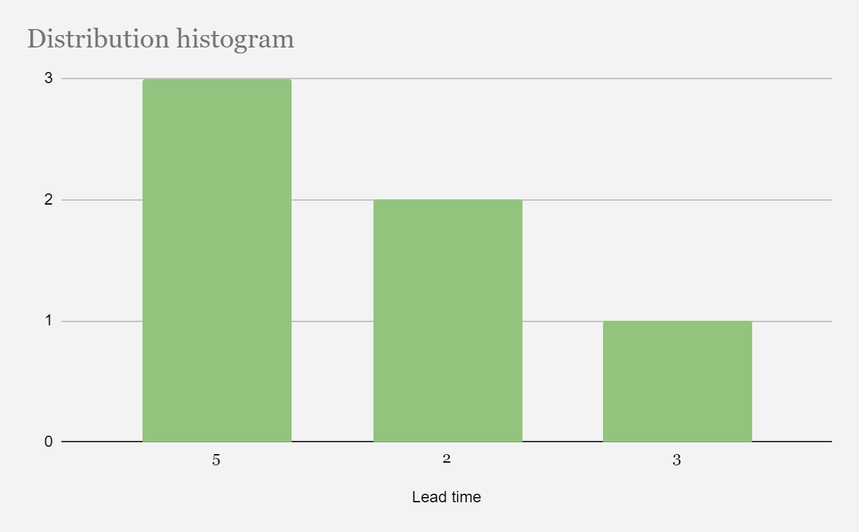
3-1. Figure: Lead time (21/12/2023)
- Gantt fulfilment:
  - As of the current date, the project is progressing with a mix of completed and ongoing tasks. Accomplishments include the collection of data from external factors, the development of a Python server capable of handling REST requests with the added complexity of multithreaded operations, and the successful creation of an automated testing method via Jenkins. Additionally, the team has effectively completed the development of the login functionality and the registration system, along with the creation of the home page.
  - The tasks of making simulations with threads and collecting real-time data have also been finalised, indicating strong progress in backend operations and data handling capabilities. Furthermore, user interface elements such as the user edition and search page have been established, demonstrating progress in frontend development.
  - While these achievements mark significant milestones, the project is currently still focusing on a few critical tasks that are in progress. These include making predictions through the web, implementing a bot via Gmail, and searching historical data on the web. The final stages of the project will involve creating the forum system and developing a recommendation system to suggest forum topics, which are yet to commence. The completion of these remaining tasks will be crucial for the project to fully meet its objectives. In the figure below the Gantt until this day can be seen (2-2. Figure: Gantt diagram (21/12/2023)).
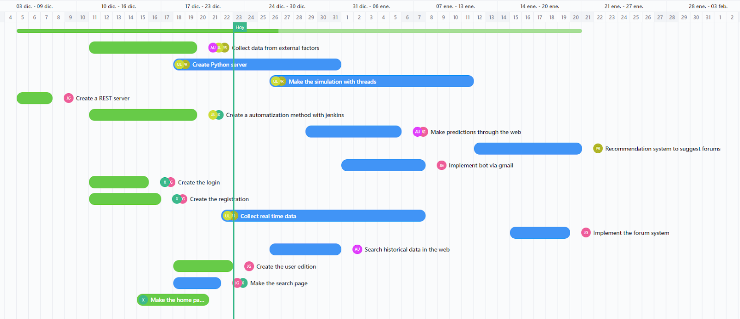
3-2. Figure: Gantt diagram (21/12/2023)
Action Items:
- Complete the new PBIs for the next product delivery:
  - The next service delivery has been planned to be done at the end of the Christmas, so the PBIs that are established to be fulfilled have to be done by the day 8th of January.
- Maintain a similar Lead Time:
  - Make a concerted effort to manage the Lead Time and ensure that the duration of the tasks is similar as the one planned in the Gantt diagram. This involves careful planning and coordination to optimize workflow efficiency.
- Maintain the good performance of the team for this week:
  - Uphold the positive performance exhibited by the team in the previous weeks. Encourage team working, communication between the members and focus on achieving individual and collective goals to fulfil the deadlines established.
Conclusions:
The project has effectively met several of its planned objectives with the successful completion of foundational tasks such as data collection, server setup, and test automation. These completed tasks have laid the groundwork for subsequent phases. Presently, efforts are concentrated on finalizing predictive features and bot integration, with some tasks nearing completion past their projected dates. The commencement of the forum system and recommendation engine is imminent, marking the final stage of this project's timeline. Despite some delays, the progress is aligned with critical milestones, and the project is moving forward with a strong commitment to adhere to the remaining schedule for timely completion.

Fifth Week (08/01/2024 – 14/01/2024)

Service delivery meeting (08/01/2024)
Date: 08-01-2024
Time: From 08:00 to 08:30
Location: Mondragon University 11310
Attendees:
- Service Delivery Manager: Unai
- Service Request Manager: Peru
- Team: Xabat, Andoni and Julen
Agenda:
- Review the performance of the team during the service delivery.
- Discuss the quality of the product developed.
- Discuss if the lead time is appropriate.
- Analyse the Gantt diagram fulfilment.
Discussion Summary
- Performance during the service delivery:
  - The team's performance during the service delivery has been good. The majority of the objectives set for the service delivery have been achieved, and the results obtained have been as desired. Team members have worked well together, dividing various tasks among themselves, and following the planned schedule.
- Quality of the product developed:
  - The recently developed product meets the desired standards in terms of quality and functionality. The team collaborated effectively throughout the process, contributing their skills and expertise. The end result reflects a balanced and efficient development effort, with each team member playing a crucial role. The outcome product aligns well with the expectations.
- Lead time:
  - After Christmas, 2 PIBs have been made in 9 days. Compared to the previous histogram it may seem that not so many PIBs have been made, however, the PIBs that have been made have been of longer duration, i.e. of more time and more difficulty. Therefore, it can be said that the same progress has been made as planned. In the image below the lead time up to this point can be seen (3-1. Figure: Lead time (08/01/2024)).
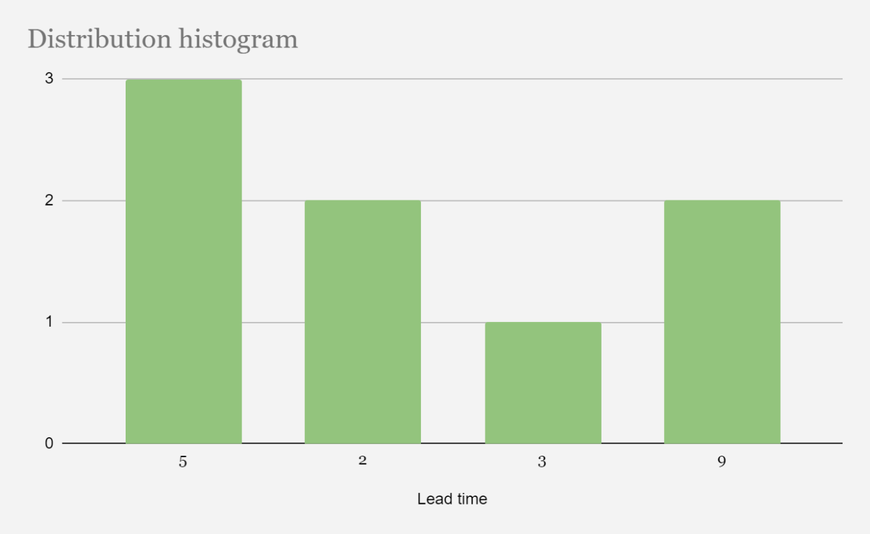
4-1. Figure: Lead time (08/01/2024)
- Gantt fulfilment:
  - Several tasks have been completed, as indicated by the solid filled bars, such as "Create a REST server," "Create the login," and "Create the registration." Ongoing tasks, partially completed, include "Collect data from external factors," "Create Python server," "Make the simulation with threads," and "Collect real-time data." These tasks are crucial for data handling and backend server setup.
  - Additionally, automation processes are being established with Jenkins, which will contribute to the efficiency and reliability of the deployment process. Another component in progress is the implementation of a bot via Gmail, which may serve as part of the user interaction or notification system.
  - Further along the timeline, tasks such as "Make predictions through the web," "Recommendation system to suggest forums," and "Implement the forum system" are scheduled. These will likely contribute to the user interface and the service's capability to provide stock market predictions and related community features.
  - "Search historical data on the web" is also planned, which implies the system will integrate historical analysis into its prediction models. This comprehensive scheduling ensures that the project's various components are developed in a structured and timely manner. In the figure below the Gantt until this day can be seen (3-2. Figure: Gantt diagram (08/01/2024)).
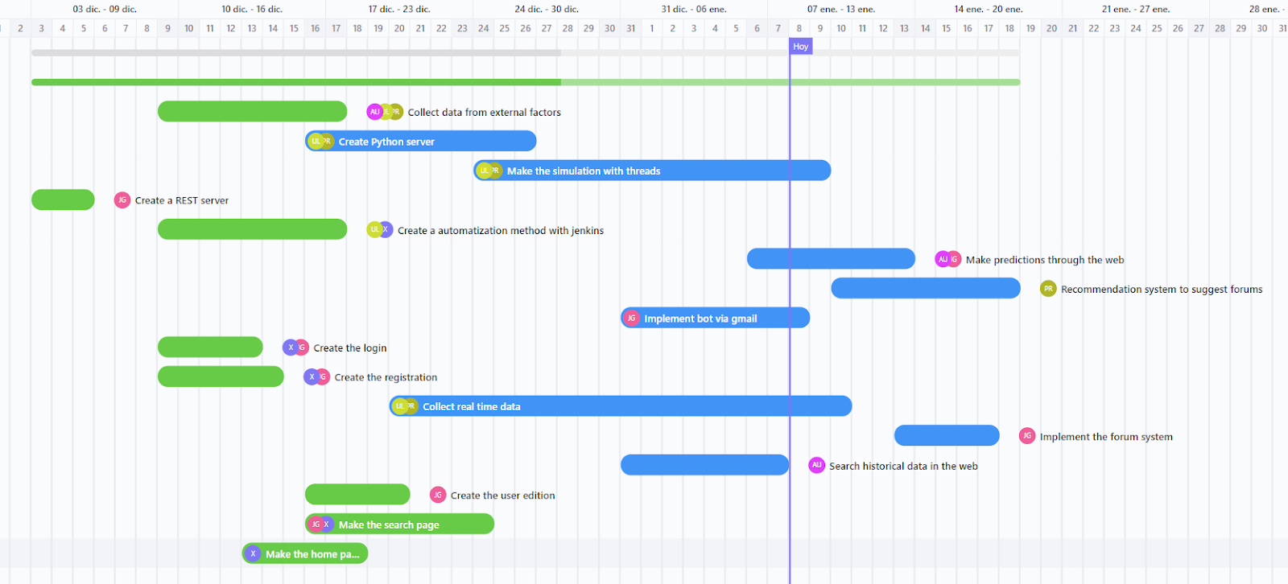
4-2. Figure: Gantt diagram (08/01/2024)
Action Items:
- Complete the PBIs for data decision-making:
  - Ensure the successful closure of outstanding Product Backlog Items (PBIs) related to data decision-making. This involves ending tasks, documenting outcomes, and achieving alignment with project objectives.
- Strive to keep the WIP below the set limit of 5:
  - Make a concerted effort to manage the Work in Progress (WIP) and ensure that the number of concurrent tasks remains below the established limit of 5. This involves careful planning and coordination to optimize workflow efficiency.
- Maintain the good performance of the team for this week:
  - Uphold the positive performance exhibited by the team in the previous week. Encourage collaboration, effective communication, and a focus on achieving individual and collective goals to sustain the high standard of work.
- Minimise the lead time:
  - The lead time can be minimized if more PBIs are made. Lead time being decreased means the team is working at his maximum capacity and the effort needed is being made.
Conclusions:
In conclusion, the team had a positive week with effective collaboration. The WIP limit of 5 PBIs proved suitable, and no major issues were encountered. Two tasks from the previous week require immediate attention, while new priorities include creating the user edition and implementing a data impact analysis. Action items involve completing pending PBIs, preventing blockages, staying below the WIP limit, and maintaining the team's strong performance.

Replenishment and Commitment Meeting (08/01/2024)
Date: 08-01-2024
Time: From 8:30 to 9:00
Location: Mondragon University 11310
Attendees:
- Service Delivery Manager: Unai
- Service Request Manager: Peru
- Team: Xabat, Andoni and Julen
Agenda:
- Review the performance of the team during the past week.
- Discuss if the limit of the WIP is suitable for the team.
- Check for the presence of blocked items.
- Decide the priority of the PBIs selected.
- Discuss if new PBIs are required for the correct development of the project.
Discussion Summary
- Performance in the past week:
  - The team's performance in the last week has been good, but a little slower than expected, even without major problems. The achievement of the objectives has gone smoothly. The team members have worked well together, dividing the different tasks, and following the planned schedule.
- WIP suitability:
  - The PBI limit that was decided has been adequate in terms of project development, as only 5 PBIs were developed simultaneously. In fact, it has been bigger than the one required as at this stage of the project the team members have focused on certain tasks by helping each other.
- Blocked items:
  - So far, the group has not encountered any major problems with the tasks assigned, so there are no items that are blocked.
- PBI priority selection:
  - The tasks that could not be completed earlier have now been completed successfully and without any problems for the team members.
  - The tasks with the highest priority now will be the collection of external data and the implementation of the threaded simulation.
- New PBIs:
  - No new targets to be included this week.
Action Items:
- Complete the PBIs for data decision-making:
  - Ensure the successful closure of outstanding Product Backlog Items (PBIs) related to data decision-making. This involves ending tasks, documenting outcomes, and achieving alignment with project objectives.
- Attempt to prevent the occurrence of blocked items:
  - Implement proactive measures to identify and address potential obstacles before they escalate. Foster open communication within the team to promptly resolve any issues hindering progress.
- Strive to keep the WIP below the set limit of 5:
  - Make a concerted effort to manage the Work in Progress (WIP) and ensure that the number of concurrent tasks remains below the established limit of 5. This involves careful planning and coordination to optimize workflow efficiency.
- Maintain the good performance of the team for this week:
  - Uphold the positive performance exhibited by the team in the previous week. Encourage collaboration, effective communication, and a focus on achieving individual and collective goals to sustain the high standard of work.
Conclusions:
In conclusion, the team had a positive week with effective collaboration and adequate project progress. The WIP limit of 5 PBI was adequate, and no major problems were encountered. The team will focus on the high priority tasks to keep the project on track. Action points are to complete outstanding WIPs, avoid bottlenecks, stay below the WIP limit, and maintain good team performance.

Daily meeting (08/01/2024)
Date: 08-01-2024
Time: From 8:30 to 9:00
Location: Mondragon University 11310
Attendees:
- Service Delivery Manager: Unai
- Service Request Manager: Peru
- Team: Xabat, Andoni and Julen
Agenda:
- Coordination and planning for the day ahead.
Daily Minutes:
- What did I do yesterday?
  - Unai:
    - Finish the first version of the simulation of the application's operation with threads.
  - Xabat:
    - Edit the CSS of the website, i.e. style it to suit the needs of the team. Create logic to show data in graphs in addition to the already existing tables.
  - Peru:
    - Accommodate, shape, and adapt the csv of external factors to the original csv, the stock exchange one.
  - Andoni:
    - Continue with the realisation of the LSTM model.
  - Julen:
    - Accommodate, shape, and adapt the csv of external factors to the original csv, the stock exchange csv.
- What will I do today?
  - Unai:
    - Fit the operating system simulation to the real data that we collect.
  - Xabat:
    - Arrange the received data to display them correctly in the graphs.
  - Peru:
    - Finish the adaptation of the csv and create the definitive one.
  - Andoni:
    - Finish the LSTM model.
  - Julen:
    - Finish the adaptation of the csv and create the definitive one.
- What is in my way?
  - Unai:
    - Making prediction with the data obtained
  - Xabat:
    - Nothing to comment.
  - Peru:
    - Adapt and adapt all dates in the csv and eliminate those that are not necessary for a correct analysis.
  - Andoni:
    - All correct
  - Julen:
    - Adapt and adapt all dates in the csv and eliminate those that are not necessary for a correct analysis.
Open Discussion:
In the meeting held on 08-01-2024 at Mondragon University, the team discussed and coordinated plans for the day. The Service Delivery Manager reported completing the first version of the application's operation simulation. Team members shared their progress and tasks for the day, focusing on CSS editing, data visualization, CSV adaptation, LSTM model completion, and addressing challenges such as data prediction and CSV date adjustments. The team is actively working towards their respective goals to ensure a smooth workflow.

Daily meeting (09/01/2024)
Date: 09-01-2024
Time: From 8:30 to 9:00
Location: Mondragon University 11310
Attendees:
- Service Delivery Manager: Unai
- Service Request Manager: Peru
- Team: Xabat, Andoni and Julen
Agenda:
- Coordination and planning for the day ahead.
Daily Minutes:
- What did I do yesterday?
  - Unai:
    - Improve operating systems simulation’s synchronisation with “river crossing” synchronisation.
  - Xabat:
    - Arrange the received data to display them correctly in the graphs.
  - Peru:
    - Finish the adaptation of the csv and create the definitive one.
  - Andoni:
    - Finish the LSTM model.
  - Julen:
    - Finish the adaptation of the csv and create the definitive one.
- What will I do today?
  - Unai:
    - Finish the implementation of “river crossing” and start painting graphs in node-red.
  - Xabat:
    - Upload the made version of node-red to Google Cloud and start painting graphs.
  - Peru:
    - Find more data (social and political) and finish the last CSV.
  - Andoni:
    - Adapt the model to the new data.
  - Julen:
    - Find more data (social and political) and finish the last CSV.
- What is in my way?
  - Unai:
    - Problems implementing the new synchronisation technique with the previous version of the simulation.
  - Xabat:
    - Nothing to comment.
  - Peru:
    - Nothing to comment.
  - Andoni:
    - The prediction is too accurate to be well done.
  - Julen:
    - Nothing to comment.
Open Discussion:
In today's meeting at Mondragon University, the team highlighted significant strides: Unai, Xabat, Peru, Andoni, and Julen shared accomplishments from the previous day and set clear goals for today. While Unai grapples with challenges in the new synchronisation technique and Andoni raises concerns about the model's prediction accuracy, the team maintains a steadfast focus on their tasks. The open communication and dedication reflected in the absence of reported obstacles by other members suggest promising progress towards the day's set objectives.

Daily meeting (10/01/2024)
Date:10-01-2024
Time: From 8:30 to 9:00
Location: Mondragon University 11310
Attendees:
- Service Delivery Manager: Unai
- Service Request Manager: Peru
- Team: Xabat, Andoni and Julen
Agenda:
- Coordination and planning for the day ahead.
Daily Minutes:
- What did I do yesterday?
  - Unai:
    - Finish the implementation of “river crossing” and start painting graphs in node-red.
  - Xabat:
    - Upload the made version of node-red to Google Cloud and start painting graphs.
  - Peru:
    - Find more data (social and political) and finish the last CSV. Start the web scraping for getting real time data.
  - Andoni:
    - Adapt the model to the new data.
  - Julen:
    - Find more data (social and political) and finish the last CSV. Start the web scraping for getting real time data.
- What will I do today?
  - Unai:
    - Fix the operating system simulation and start implementing it on the web.
  - Xabat:
    - Try to implement email sending in the cloud.
  - Peru:
    - Finish the web scraping part and start implementing this in the project.
  - Andoni:
    - Adapt the model to the final complete dataset and try to run it.
  - Julen:
    - Finish the web scraping part and start implementing this in the project.
- What is in my way?
  - Unai:
    - Problems implementing the new synchronization technique with the previous version of the simulation.
  - Xabat:
    - Locally works but once in the cloud no
  - Peru:
    - Search reliable and free real time data on the internet.
  - Andoni:
    - Nothing to comment.
  - Julen:
    - Search reliable and free real time data on the internet.
Open Discussion:
In today's meeting at Mondragon University, the team highlighted significant strides: Unai, Xabat, Peru, Andoni, and Julen shared accomplishments from the previous day and set clear goals for today. While Unai grapples with challenges in the new synchronization technique and Peru and Julen raise concerns about the reliability of the real time data of the scraping, the team maintains a steadfast focus on their tasks. The open communication and dedication reflected in the absence of reported obstacles by other members suggest promising progress towards the day's set objectives.

Daily meeting (11/01/2024)
Date: 11-01-2024
Time: From 8:00 am to 9:00 am
Location: Mondragon University 11310
Attendees:
- Service Delivery Manager: Unai
- Service Request Manager: Peru
- Team: Xabat, Andoni and Julen
Agenda:
- Coordination and planning for the day ahead.
Daily Minutes:
- What did I do yesterday?
  - Unai:
    - Fix the operating system simulation and start implementing it on the web.
  - Xabat:
    - Upload the made version of node-red to Google Cloud and start painting graphs.
  - Peru:
    - Find more data (social and political) and finish the last CSV. Start the web scraping for getting real time data.
  - Andoni:
    - Adapt the model to the new data.
  - Julen:
    - Find more data (social and political) and finish the last CSV. Start the web scraping for getting real time data.
- What will I do today?
  - Unai:
    - Test the simulation code.
  - Xabat:
    - Start doing the interface of the chat.
  - Peru:
    - Exploratory data analysis of the different data we use.
  - Andoni:
    - Upload the model of the prophet to cloud.
  - Julen
    - Start doing the code of the chat.
- What is in my way?
  - Unai:
    - Making test with threads
  - Xabat:
    - Nothing to comment.
  - Peru:
    - Nothing to comment.
  - Andoni:
    - How to upload the AI correctly to the cloud
  - Julen:
    - Nothing to comment.
Open Discussion:
In today's Mondragon University meeting, the team highlighted progress and commitment. Unai fixed the OS simulation and faced challenges with threads. Xabat uploaded node-red to Google Cloud and started graph visualization. Peru and Julen raised concerns about the reliability of real-time data from web scraping. Andoni adapts the model, seeking guidance on cloud uploading. Goals for today include testing, interface development, data analysis, model uploading, and chat code. Despite challenges, open communication prevails, and the team is dedicated to achieving daily objectives.

Daily meeting (12/01/2024)
Date: 12-01-2024
Time: From 8:00 am to 9:00 am
Location: Mondragon University 11310
Attendees:
- Service Delivery Manager: Unai
- Service Request Manager: Peru
- Team: Xabat, Andoni and Julen
Agenda:
- Coordination and planning for the day ahead.
Daily Minutes:
- What did I do yesterday?
  - Unai:
    - Test the simulation code.
  - Xabat:
    - Start doing the interface of the chat.
  - Peru:
    - Exploratory data analysis of the different data we use.
  - Andoni:
    - Upload the model of the prophet to cloud.
  - Julen:
    - Start doing the code of the chat.
- What will I do today?
  - Unai:
    - Finish the simulation test and start painting it in the web.
  - Xabat:
    - Try to print the chat messages.
  - Peru:
    - Finish the search section.
  - Andoni:
    - Upload the model of the prophet to cloud.
  - Julen
    - Delete user function and something else.
- What is in my way?
  - Unai:
    - Simulation of semaphores
  - Xabat:
    - Msg doesn’t work.
  - Peru:
    - IPC correction
  - Andoni:
    - Create the image in cloud.
  - Julen:
    - Nothing to comment.
Open Discussion:
In today's Mondragon University meeting, the team provided updates on their respective tasks and demonstrated commendable progress and dedication. A notable achievement was the resolution of challenges in the OS simulation by one team member, while another successfully initiated the deployment of node-red on Google Cloud and commenced graph visualization work. Concerns were raised regarding the reliability of real-time data obtained through web scraping, particularly in the context of data analysis efforts.

Sixth week (15/01/2024-21/01/2024)

Replenishment and Commitment Meeting (15/01/2024)
Date: 15-01-2024
Time: From 8:00 to 8:30
Location: Mondragon University 11310
Attendees:
- Service Delivery Manager: Unai
- Service Request Manager: Peru
- Team: Xabat, Andoni and Julen
Agenda:
- Review the performance of the team during the past week.
- Discuss if the limit of the WIP is suitable for the team.
- Check for the presence of blocked items.
- Decide the priority of the PBIs selected.
- Discuss if new PBIs are required for the correct development of the project.
Discussion Summary
- Performance in the past week:
  - The team's performance over the past week has been positive, though slightly slower than anticipated, despite the absence of significant challenges. We successfully met our objectives without encountering major issues. The collaboration among team members was effective, with tasks being distributed and executed cohesively according to the planned schedule.
- WIP suitability:
  - The WIP limit that was decided has been bigger than the one originally designed, as only 4 PBIs were developed simultaneously. As a result, it has been decided to reduce the WIP limit from 5 to 4, in order to reduce the quantity of PBIs that are done at the same time.
- Blocked items:
  - So far, the group has not encountered any major problems with the tasks assigned, so there are no items that are blocked.
- PBI priority selection:
  - The tasks that could not be completed earlier have now been completed successfully and without any problems for the team members.
  - The tasks with the highest priority at the moment will be to make predictions through the web and finish the simulation with threads. The other PBI that are also in progress are searching for historical data in the web and implementation of the forum system.
- New PBIs:
  - No new targets to be included this week.
Action Items:
- Complete the PBIs for data decision-making:
  - Make sure to complete any remaining tasks related to data decisions. This includes finishing up the work, noting down what's done, and making sure everything aligns with the project goals.
- Attempt to prevent the occurrence of blocked items:
  - Take steps to find and solve potential problems before they become big issues. Keep the team talking so we can quickly fix anything that might slow us down.
- Strive to keep the WIP below the set limit of 4:
  - Make a concerted effort to manage the Work in Progress (WIP) and ensure that the number of concurrent tasks remains below the recently established limit of 4. This involves careful planning and coordination to optimize workflow efficiency.
- Maintain the good performance of the team for this week:
  - Continue doing well as a team, like it was done last week. Encourage collaboration, effective communication, and a focus on achieving individual and collective goals to sustain the high standard of work.
Conclusions:
In summary, the team's performance last week was positive, though slightly slower than expected. Adjustments were made to the WIP limit, reducing it from 5 to 4 to optimize task management. No major issues or blocked items were encountered. High-priority PBIs for the coming week include making web predictions and finalizing the simulation. No new targets were added. Action items focus on completing data decision-making PBIs, preventing issues, and maintaining the WIP below 4. The team aims to sustain collaboration and performance levels achieved last week.

Daily meeting (15/01/2024)
Date: 15-01-2024
Time: From 8:30 to 9:00
Location: Mondragon University 11310
Attendees:
- Service Delivery Manager: Unai
- Service Request Manager: Peru
- Team: Xabat, Andoni and Julen
Agenda:
- Coordination and planning for the day ahead.
Daily Minutes:
- What did I do yesterday?
  - Unai:
    - Finish the simulation test and start painting it in the web.
  - Xabat:
    - Print the chat messages.
  - Peru:
    - Finish the search section.
  - Andoni:
    - Upload the model of the prophet to cloud.
  - Julen:
    - Delete user function and something else.
- What will I do today?
  - Unai:
    - Continue finishing the simulation tests and start painting it in the web.
  - Xabat:
    - Start implementing the simulation to the web.
  - Peru:
    - Implement the explorator and data analysis in the Python server.
  - Andoni:
    - Upload the model of the prophet to cloud.
  - Julen
    - Implement the explorator and data analysis in the Python server.
- What is in my way?
  - Unai:
    - Nothing to comment.
  - Xabat:
    - Everything is correct.
  - Peru:
    - Do tests in Python.
  - Andoni:
    - Denormalize the prediction
  - Julen:
    - Dataset is poor and is necessary to fix it.
Open Discussion:
In the meeting on 15-01-2024 at Mondragon University, the team discussed coordination and planning for the day. The Service Delivery Manager, Unai, provided updates on finishing simulation tests and web integration. Xabat reported progress in printing chat messages, while Peru focused on completing the search section. Andoni worked on uploading the Prophet model to the cloud, and Julen handled user function deletion. Plans for the day included continuing simulation tests and web integration, implementing the simulation on the web, and working on data analysis and exploration in the Python server. Challenges mentioned included testing in Python, denormalizing predictions, and addressing a poor dataset. The team is actively addressing these issues to meet their objectives.

Daily meeting (16/01/2024)
Date: 16-01-2024
Time: From 8:00 to 8:30
Location: Mondragon University 11310
Attendees:
- Service Delivery Manager: Unai
- Service Request Manager: Peru
- Team: Xabat, Andoni and Julen
Agenda:
- Coordination and planning for the day ahead.
Daily Minutes:
- What did I do yesterday?
  - Unai:
    - Continue finishing the simulation tests and start painting it in the web.
  - Xabat:
    - Start implementing the simulation to the web.
  - Peru:
    - Implement the explorator and data analysis in the Python server.
  - Andoni:
    - Upload the model of the prophet to cloud.
  - Julen
    - Implement the explorator and data analysis in the Python server.
- What will I do today?
  - Unai:
    - Start implementing message passing in operating simulation.
  - Xabat:
    - Implement the simulation’s graph in Node-Red.
  - Peru:
    - Finish the explorator and connect with Node-Red.
  - Andoni:
    - Pass prediction data from AI server to Node-Red.
  - Julen
    - Accommodate the JSON messages for data searches.
- What is in my way?
  - Unai:
    - Nothing to comment.
  - Xabat:
    - Nothing to comment.
  - Peru:
    - Nothing to comment.
  - Andoni:
    - Subtracting data from the model
  - Julen:
    - Dataset is not done correctly.
Open Discussion:
In conclusion, the meeting held on 16-01-2024 at Mondragon University 11310 resulted in a clear plan for the day ahead. The team, consisting of the Service Delivery Manager Unai, Service Request Manager Peru, and team members Xabat, Andoni, and Julen, discussed their individual tasks and progress. Unai is focused on message passing in operating simulation, Xabat on implementing the simulation's graph in Node-Red, Peru on completing the explorer and connecting with Node-Red, Andoni on passing prediction data from the AI server to Node-Red, and Julen on accommodating JSON messages for data searches. The team highlighted minimal obstacles, with Andoni facing challenges in subtracting data from the model and Julen encountering issues with the dataset's correctness. Overall, the meeting ensured coordination and alignment towards achieving the day's goals in the ongoing project.

Daily meeting (17/01/2024)
Date: 17-01-2024
Time: From 8:00 to 8:30
Location: Mondragon University 11310
Attendees:
- Service Delivery Manager: Unai
- Service Request Manager: Peru
- Team: Xabat, Andoni and Julen
Agenda:
- Coordination and planning for the day ahead.
Daily Minutes:
- What did I do yesterday?
  - Unai:
    - Start implementing message passing in operating simulation.
  - Xabat:
    - Implement the simulation’s graph in Node-Red.
  - Peru:
    - Finish the explorator and connect with Node-Red.
  - Andoni:
    - Pass prediction data from AI server to Node-Red.
  - Julen:
    - Accommodate the JSON messages for data searches.
- What will I do today?
  - Unai:
    - Record the video and continue implementing message passing.
  - Xabat:
    - Record the video.
  - Peru:
    - Record and edit the video.
  - Andoni:
    - Record the video.
  - Julen:
    - Record the video.
- What is in my way?
  - Unai:
    - There is a deadlock in the simulation.
  - Xabat:
    - Nothing to comment.
  - Peru:
    - Nothing to comment.
  - Andoni:
    - Nothing to comment.
  - Julen:
    - Nothing to comment.
Open Discussion:
In today's Mondragon University meeting, the team provided updates on their respective tasks and demonstrated commendable progress and dedication. A notable achievement was finishing the data exploratory analysis scripts, while another successfully initiated the deployment of this one on node-red. Concerns were raised regarding the deadlock of the thread simulation but there wasn't any problem with the video recording, and all went really well.

Daily meeting (18/01/2024)
Date: 18-01-2024
Time: From 8:00 to 8:30
Location: Mondragon University 11310
Attendees:
- Service Delivery Manager: Unai
- Service Request Manager: Peru
- Team: Xabat, Andoni and Julen
Agenda:
- Coordination and planning for the day ahead.
Daily Minutes:
- What did I do yesterday?
  - Unai:
    - Record the video and continue implementing message passing.
  - Xabat:
    - Record the video.
  - Peru:
    - Record and edit the video.
  - Andoni:
    - Record the video.
  - Julen:
    - Record the video.
- What will I do today?
  - Unai:
    - Finish the message passing implementation in Operating Simulation and include in Node-Red.
  - Xabat:
    - Unify all using node red: message XML, scrapping, complete operating simulation.
  - Peru:
    - Finish the video and test in python.
  - Andoni:
    - Make the prediction in Node-Red.
  - Julen:
    - Implement scrapping and XML message.
- What is in my way?
  - Unai:
    - There is a deadlock in the simulation.
  - Xabat:
    - Nothing to comment.
  - Peru:
    - Troubles testing AI server.
  - Andoni:
    - Nothing to comment.
  - Julen:
    - Nothing to comment.
Open Discussion:
During today's meeting at Mondragon University on 19-01-2024, the team reported significant progress and dedication to their tasks. Notably, Unai advanced in video recording and message passing implementation, Xabat achieved video recording unification using Node-Red, and Peru successfully recorded and edited the video. Looking forward, the team outlined their goals, including finalizing message passing in the Operating Simulation, unifying processes using Node-Red, and conducting Python testing. Some concerns were raised about a simulation deadlock, but the overall video recording process proceeded smoothly, showcasing the team's efficient collaboration and problem-solving skills.

Daily meeting (19/01/2024)
Date: 19-01-2024
Time: From 8:00 to 8:30
Location: Mondragon University 11310
Attendees:
- Service Delivery Manager: Unai
- Service Request Manager: Peru
- Team: Xabat, Andoni and Julen
Agenda:
- Coordination and planning for the day ahead.
Daily Minutes:
- What did I do yesterday?
  - Unai:
    - Finish the message passing implementation in Operating Simulation and include in Node-Red.
  - Xabat:
    - Unify all using Node-Red: message XML, scrapping, complete operating simulation.
  - Peru:
    - Finish the video and test in python.
  - Andoni:
    - Make the prediction in Node-Red.
  - Julen:
    - Implement scrapping and XML message.
- What will I do today?
  - Unai:
    - Do the cloud again.
  - Xabat:
    - Put all together.
  - Peru:
    - Do the test Scrapping.
  - Andoni:
    - Finish the prediction unnormalization and do the graphics.
  - Julen:
    - Test of the java
- What is in my way?
  - Unai:
    - Google Cloud was suspended by Google.
  - Xabat:
    - Google cloud failed.
  - Peru:
    - Mock functions of scrapping
  - Andoni:
    - Do the model without normalising it.
  - Julen:
    - Test Simulation maker
Open Discussion:
During today's meeting at Mondragon University on 19-01-2024, the team reported significant progress and dedication to their tasks. Notably, Unai advanced in video recording and message passing implementation, Xabat achieved video recording unification using Node-Red, and Peru successfully recorded and edited the video. Looking forward, the team outlined their goals, including finalizing message passing in the Operating Simulation, unifying processes using Node-Red, and conducting Python testing. Some concerns were raised about a simulation deadlock, but the overall video recording process proceeded smoothly, showcasing the team's efficient collaboration and problem-solving skills.

Seventh week (22/01/2024-24/01/2024)

Replenishment and Commitment Meeting (22/01/2024)
Date: 22-01-2024
Time: From 8:30 to 9:00
Location: Mondragon University 11310
Attendees:
- Service Delivery Manager: Unai
- Service Request Manager: Peru
- Team: Xabat, Andoni and Julen
Agenda:
- Review the performance of the team during the past week.
- Discuss if the limit of the WIP is suitable for the team.
- Check for the presence of blocked items.
- Decide the priority of the PBIs selected.
- Discuss if new PBIs are required for the correct development of the project.
- Discuss if any PBI has to be removed from this version of the project.
Discussion Summary
- Performance in the past week:
  - The team's performance in the last week has been good, but a little slower than expected, as the Google Cloud server was suspended. As a result, the server has to be made again, which took one day to recreate and another one to verify its correct functioning. The team members have worked well together, dividing the different tasks, and following the planned schedule.
- WIP suitability:
  - The PBI limit that was decided has been adequate in terms of project development, as only 3 PBIs were developed simultaneously. In fact, it has been bigger than the one required, as at this stage of the project the team members have focused on certain tasks by helping each other.
- Blocked items:
  - So far, the group has encountered major problems with the Google Cloud server suspendance, which blocked some PBIs until the server was recreated.
- PBI priority selection:
  - The tasks that could not be completed earlier have now been completed successfully and without any problems for the team members.
  - The tasks with the highest priority now will be the search of historical data on the web and making the prediction through the web.
- New PBIs:
  - No new targets to be included this week.
- Removed PBIs:
  - As a result of the recent troubles with the server, the PBI of making the recommendation system has been removed, leaving it as a future line.
Action Items:
- Complete the PBIs for prediction making:
  - Ensure the successful closure of outstanding Product Backlog Items (PBIs) related to prediction making. This involves ending tasks, documenting outcomes, and achieving alignment with project objectives.
- Attempt to prevent the occurrence of blocked items:
  - Implement proactive measures to identify and address potential obstacles before they escalate. Foster open communication within the team to promptly resolve any issues hindering progress.
- Strive to keep the WIP below the set limit of 2:
  - Make a concerted effort to manage the Work in Progress (WIP) and ensure that the number of concurrent tasks remains below the now established limit of 2. This involves careful planning and coordination to optimise workflow efficiency.
- Maintain the good performance of the team for this week:
  - Uphold the positive performance exhibited by the team in the previous week. Encourage collaboration, effective communication, and a focus on achieving individual and collective goals to sustain the high standard of work, in order to do the last deliverables of the product.
Conclusions:
In this week's Replenishment and Commitment Meeting (22/01/2024), the team acknowledged a minor setback with the Google Cloud server, causing a one-day delay. Despite this, they collaborated effectively, surpassing the agreed Work in Progress (WIP) limit. Blocked items were primarily due to the server issue, prompting a commitment to proactive measures. Priority PBIs were successfully addressed, focusing on completing pending tasks and prioritizing the search for historical data and prediction through the web. No new PBIs were introduced, and the recommendation system PBI was removed due to server challenges. Action items include completing PBIs for prediction making, preventing blocked items, managing WIP below the limit, and maintaining positive team performance for the upcoming week, ensuring successful project delivery.

Daily meeting (22/01/2024)
Date: 22-01-2024
Time: From 8:30 to 9:00
Location: Mondragon University 11310
Attendees:
- Service Delivery Manager: Unai
- Service Request Manager: Peru
- Team: Xabat, Andoni and Julen
Agenda:
- Coordination and planning for the day ahead.
Daily Minutes:
- What did I do yesterday?
  - Unai:
    - Do the cloud again.
  - Xabat:
    - Put all together.
  - Peru:
    - Do the test Scrapping.
  - Andoni:
    - Finish the prediction unnormalized and do the graphics.
  - Julen:
    - Test of the java.
- What will I do today?
  - Unai:
    - Make real prediction in the simulation.
  - Xabat:
    - Upload the photos of the search information dynamically; html, CSS, and JavaScript of the accordion to show the info and images. Fix the error that the forum does not save the new messages.
  - Peru:
    - Test of the python functions.
  - Andoni:
    - Upload the new prophet model.
  - Julen:
    - Trigger to add user to the forum they sign up and fix errors.
- What is in my way?
  - Unai:
    - Making real predictions with simulations.
  - Xabat:
    - Forum’s new messages are not saved.
  - Peru:
    - Making the tests in the client of Python.
  - Andoni:
    - The prediction is not as good as expected.
  - Julen:
    - Forum’s new messages are not saved.
Open Discussion:
In the meeting held on 22-01-2024 at Mondragon University, the team engaged in coordination and planning for the day. Plans for today involve real predictions in the simulation for Unai, dynamic photo uploads and forum error fixing for Xabat, Python function testing for Peru, uploading the new Prophet model for Andoni, and forum user addition triggering and error fixing for Julen. Challenges include making real predictions with simulations for Unai, saving new forum messages for Xabat and Julen, Python client testing for Peru, and the performance of the prediction for Andoni. The team is actively working to overcome these challenges and meet their goals for the day.

Daily meeting (23/01/2024)
Date: 23-01-2024
Time: From 8:30 to 9:00
Location: Mondragon University 11310
Attendees:
- Service Delivery Manager: Unai
- Service Request Manager: Peru
- Team: Xabat, Andoni and Julen
Agenda:
- Coordination and planning for the day ahead.
Daily Minutes:
- What did I do yesterday?
  - Unai:
    - Make real prediction in the simulation.
  - Xabat:
    - Upload the photos of the search information dynamically; html, CSS, and JavaScript of the accordion to show the info and images. Fix the error that the forum does not save the new messages.
  - Peru:
    - Test of the python functions.
  - Andoni:
    - Upload the new prophet model.
  - Julen:
    - Trigger to add user to the forum they sign up and fix errors.
- What will I do today?
  - Unai:
    - Finish making real prediction with the simulation and automatize AI tests with Jenkins.
  - Xabat:
    - Fix minor errors.
  - Peru:
    - Finish the video editing and finish AI tests.
  - Andoni:
    - Finish making real prediction with the simulation.
  - Julen:
    - Finish AI server tests.
- What is in my way?
  - Unai:
    - Making the connection between AI server and REST server.
  - Xabat:
    - Nothing to comment.
  - Peru:
    - Some tests have different structures.
  - Andoni:
    - Nothing to comment.
  - Julen:
    - Some tests have different structures.
Open Discussion:
In today's Daily Meeting on January 23, 2024, the team reported on their progress and outlined tasks for the day. Unai focused on making a real prediction in the simulation and automating AI tests with Jenkins. Xabat worked on uploading dynamic photos for search information and fixing forum-related errors. Peru conducted Python function tests, while Andoni uploaded a new Prophet model and Julen addressed forum-related tasks. For the day ahead, Unai aimed to finish the real prediction and automate AI tests, Xabat planned to fix minor errors, Peru aimed to complete video editing and AI tests, Andoni and Julen aimed to finish their respective tasks. Obstacles included Unai working on the connection between the AI server and REST server, Peru facing structural differences in some tests, and Julen encountering similar issues. Overall, the team is actively working on project tasks, with identified obstacles to be addressed promptly.

Daily meeting (24/01/2024)
Date: 24-01-2024
Time: From 8:30 to 9:00
Location: Mondragon University 11310
Attendees:
- Service Delivery Manager: Unai
- Service Request Manager: Peru
- Team: Xabat, Andoni and Julen
Agenda:
- Coordination and planning for the day ahead.
Daily Minutes:
- What did I do yesterday?
  - Unai:
    - Finish making real prediction with the simulation and automatize AI tests with Jenkins.
  - Xabat:
    - Fix minor errors.
  - Peru:
    - Finish the video editing and finish AI tests.
  - Andoni:
    - Finish making real prediction with the simulation.
  - Julen:
    - Finish AI server tests.
- What will I do today?
  - Unai:
    - Check the functionality of the simulation.
  - Xabat:
    - Prepare the demo.
  - Peru:
    - Last quality review of the product.
  - Andoni:
    - Last quality review of the product.
  - Julen:
    - Last quality review of the product.
- What is in my way?
  - Unai:
    - Nothing to comment.
  - Xabat:
    - Nothing to comment.
  - Peru:
    - Nothing to comment.
  - Andoni:
    - Nothing to comment.
  - Julen:
    - Nothing to comment.
Open Discussion:
In today's Daily Meeting on January 24, 2024, the team provided updates on their previous day's tasks and outlined their plans for the current day. Unai successfully completed the real prediction with the simulation and automated AI tests with Jenkins. Xabat addressed minor errors, Peru finished video editing and AI tests, Andoni completed the real prediction, and Julen finished AI server tests. For the day ahead, Unai aimed to check the simulation's functionality, Xabat was to prepare the demo, and Peru, Andoni, and Julen planned to conduct the last quality review of the product. No significant obstacles were reported by any team member. The team is on track to finalize the project, with tasks aligning closely with the project's completion.

Service delivery meeting (24/01/2024)
Date: 24-01-2024
Time: From 08:00 to 08:30
Location: Mondragon University 11310
Attendees:
- Service Delivery Manager: Unai
- Service Request Manager: Peru
- Team: Xabat, Andoni and Julen
Agenda:
- Review the performance of the team during the service delivery.
- Discuss the quality of the product developed.
- Discuss if the lead time is appropriate.
- Analyse the Gantt diagram fulfilment.
Discussion Summary
- Performance during the service delivery:
  - The team encountered a major problem: The cloud server was suspended. However, the team's performance during the service delivery has been good. The problem was front faced with attitude and efficiency. Team members have worked well together, dividing various tasks among themselves, and following the planned schedule.
- Quality of the product developed:
  - The recently developed product meets the desired standards in terms of quality and functionality. The team collaborated effectively throughout the process, contributing their skills and expertise. Even if the prediction made by the model it's not the most accurate one, the end result reflects a balanced and efficient development effort, with each team member playing a crucial role. The outcome product aligns well with the expectations.
- Lead time:
  - Before the last delivery, the last PBI’s have been made in 7 and 3 days. Also a 24 day lead-time PBI was finally finished. Compared to the previous histogram it may seem that not so many PIBs have been made, however, the PIBs that have been made have been of longer duration, i.e. of more time and more difficulty. Therefore, it can be said that the same progress has been made as planned. In the image below the lead time up to this point can be seen (6-1. Figure: Final lead time (24/01/2024)).
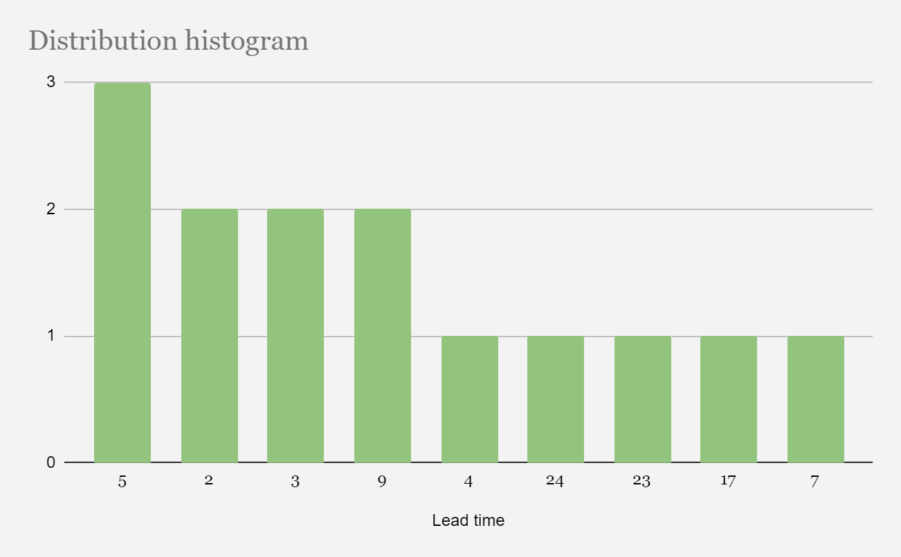
6-1. Figure: Final lead time (24/01/2024)
- Gantt fulfilment:
  - Several tasks have been completed at the beginning of this last service delivery, as indicated by the solid filled bars. Those tasks are “implement bot via Gmail” and “collect real time data”. Those tasks were done as early as possible, in order to have time to do the rest of the PBIs, which were the most crucial ones for the web page.
  - After the completion of those PBIs, in the second week of this delivery other tasks were begun and finished, such as “make prediction through the web” and “implement the forum system” apart from the “make the simulation with threads” PBI, which has to be finished later than it was expected due to some synchronisation problems.
  - Finally, the last week was used to improve the already developed web page, trying to make a more accurate prediction, and improving the simulation by making real predictions with the data simulated. All this can be seen in the image below (6-1. Figure: Final Gantt diagram (24/01/2024)).
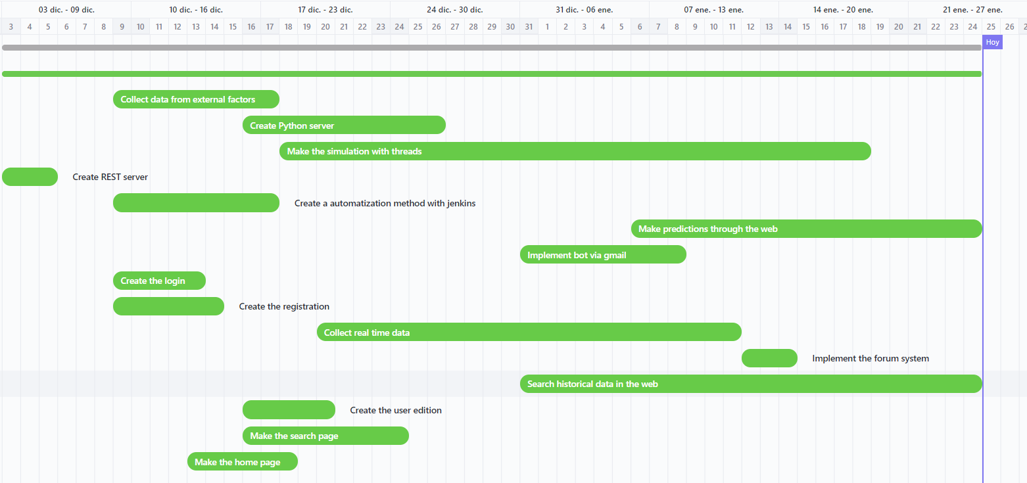
6-2. Figure: Final Gantt diagram (24/01/2024)
Action Items:
- Complete the PBIs for data decision-making:
  - Ensure the successful closure of outstanding Product Backlog Items (PBIs) related to data decision-making. This involves ending tasks, documenting outcomes, and achieving alignment with project objectives.
- Strive to keep the WIP below the set limit of 5:
  - Make a concerted effort to manage the Work in Progress (WIP) and ensure that the number of concurrent tasks remains below the established limit of 5. This involves careful planning and coordination to optimize workflow efficiency.
- Maintain the good performance of the team for this week:
  - Uphold the positive performance exhibited by the team in the previous week. Encourage collaboration, effective communication, and a focus on achieving individual and collective goals to sustain the high standard of work.
- Minimise the lead time:
  - The lead time can be minimized if more PBIs are made. Lead time being decreased means the team is working at his maximum capacity and the effort needed is being made.
Conclusions:
In conclusion, the team had a positive week with effective collaboration. The WIP limit of 2 PBIs proved suitable, and no major issues were encountered. Being the last days of the project, the priorities remain on finishing the last two PBI’s. Action items involve completing pending PBIs, preventing blockages, staying below the WIP limit, and maintaining the team's strong performance.

Strategy review meeting (24/01/2024)
Date: 24-01-2024
Time: From 08:00 to 08:30
Location: Mondragon University 11310
Attendees:
- Service Delivery Manager: Unai
- Service Request Manager: Peru
- Team: Xabat, Andoni and Julen
Agenda:
- Summarising the current state of the project.
- Presentation and discussion relevant performance metrics.
- Identifying and discussing any risks or issues that emerged during the project..
- Discuss any improvements or changes made to the Kanban process during the project.
- Share insights and lessons learned from the project.
- Discuss plans for future iterations or phases.
Discussion Summary
- Performance during the service delivery:
  - Summarising the current state of the project:
    - The project is finished. All the functionalities proposed at the beginning of the project have been fulfilled except for one, which has not been done due to lack of time but will be done in the near future.
- Presentation and discussion relevant performance metrics:
  - The correct WIP has been maintained during the course of the project, as it can be seen in the image below (6-3. Figure: WIP limit graph (24/01/2024)). In addition, the Lead Time has not been excessively long in any activity except for the simulation, as it can be seen in the image from the service delivery meeting minutes (6-1. Figure: Final lead time (24/01/2024)).
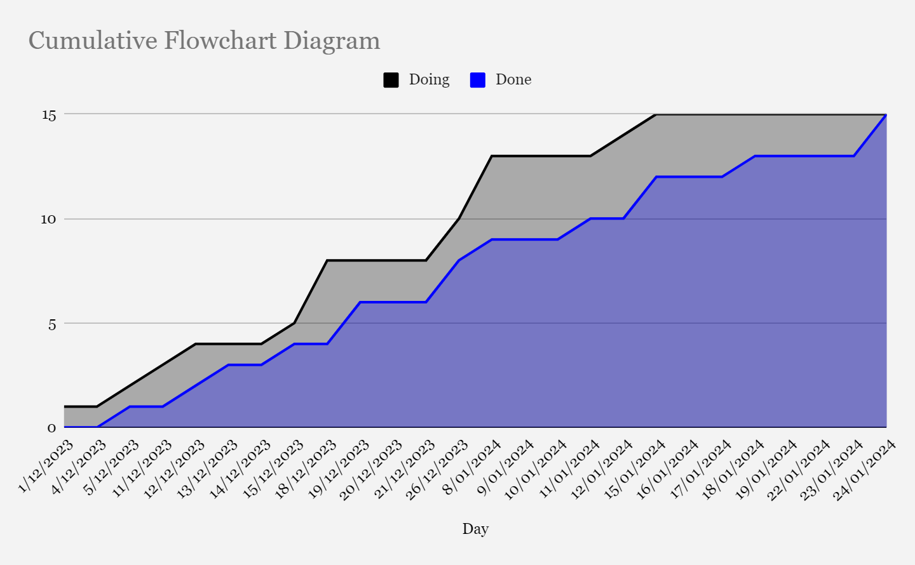
6-3. Figure: WIP limit graph (24/01/2024)
- Identifying and discussing any risks or issues that emerged during the project:
  - During the project there have been several errors that have been solved at all times. Here is a small list of the errors that occurred:
    - Errors with the dataset.
    - Error when loading images.
    - Errors with a deadlock in the simulation
    - Problems in the cloud due to alleged cryptocurrency mining
- Discuss any improvements or changes made to the Kanban process during the project:
  - During the course of the project, several changes have been made:
    - Changing the WIP limit policy
    - Changing the deadlines for some WIPs
    - Changing the prioritisation of some PBIs
    - Share insights and lessons learned from the project:
  - Several things have been learned in the project:
    - How the Google Cloud server works
    - The development of different Machine Learning models
    - How to use InfluxDB
    - To correctly organise a project using Kanban
- Discuss plans for future iterations or phases:
  - In the course of the project a PBI had to be removed:
    - For the future it will be necessary to create a forums recommendation system for the user.
Conclusions:
In summary, the project has reached its final phase successfully, achieving the implementation of all the proposed functionalities, with the exception of one that will be addressed in the near future due to time constraints. Throughout the project, an adequate Work in Progress (WIP) and a reasonable Lead Time has been maintained, with the exception of the simulation related activity. Several bugs have been identified and resolved, such as problems with the dataset, image loading and deadlock in the simulation, as well as issues in the cloud due to suspected cryptocurrency mining. Adjustments have been made to the Kanban process, including changes to the WIP limit policy, deadlines for some PBIs and prioritisation of PBIs. Lessons learned range from managing the Google Cloud server to developing Machine Learning models, using InfluxDB and properly organising a project from scratch with Kanban. As part of future iterations, it is planned to implement a forum recommendation system for the user.

